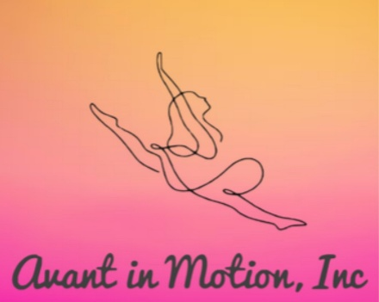
BOARD OF DIRECTORS MEETING MINUTES
December 13, 2025
at Avant Dance Studio, Amanda, Presiding
- Call to order/Invocation 1222 pm Attendees Present: Krystal, Amanda, Brenten
- Recitation of Mission Statement: Recitation of Mission Statement: “Our mission is to bring communities together to support dancers ages 5-17 by providing financial assistance and resources that eliminate barriers to team dance. We empower young performers to shine-regardless of financial background-by ensuring equitable access to training, travel and performance opportunities that build confidence, creativity and teamwork”

- Review and approval of minutes-Brenten made motion, Amanda 2nd , motion carries Minutes not available. Acknowledged

- Unfinished Business:
a) Review and approval of minutes-read Minutes unavailable, reviewed and approved at later date. Tax exemption. Will review this meeting

- Reports (No discussion here, just reports)
- Treasurer: All previous funds deposited. Disbursement from popcorn complete. Current Balance: $146.02 Earned YTD: $676.01. Awaiting funds from Cane’s fundraiser.
- Director: Awaiting funds from 11 Dec Cane’s fundraiser. Parents night out scheduled for 20 December 2025.

- Old/New Business Summary
Action items:
a.) Added addendum to bylaws for missed meeting. Requires signature from two board members. Signed by director and treasurer.
b.) Pizza fundraiser to align with parents night out on 20 December. No coordination yet. Concerns about having to prebuy tickets if done through Little Ceasars. Other possibilities mentioned are Marcos, Pizza Hut.
c.) Tax exemption. Not enough funds currently. Add addendum in Bylaws for reimbursement of personal expenses such as interest free loans to Avant in Motion.
d.) Establish a business Cashapp. Venmo requires tax ID. Will pursue
e.) Scary Larry’s pickle fundraiser. No Coordination yet. Likely aiming for February.
f.) Parent’s interest meeting focused on communication of open board policy, participation not membership, and disbursement at discretion of the board.
g.) Next meeting 8 January, 2026@ 2pm
Dismissal Time: 1249 pm Brenten Bradley

Signature:_______________________ Amanda Bradley-President Date: _________________
Signature:_______________________Renee Buentello-Secretary Date: __________________

