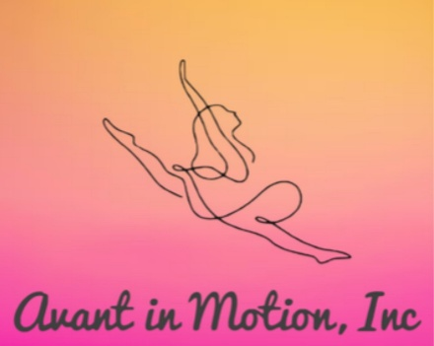
BOARD OF DIRECTORS MEETING MINUTES
January 31, 2026
January 31, 2026 at 7 pm via Facetime Video Chat, Amanda presiding
- Call to order/Invocation 7 pm Attendees Present: Amanda, Brenten, Krystal
- Recitation of Mission Statement: Recitation of Mission Statement: “Our mission is to bring communities together to support dancers ages 5-17 by providing financial assistance and resources that eliminate barriers to team dance. We empower young performers to shine-regardless of financial background-by ensuring equitable access to training, travel and performance opportunities that build confidence, creativity and teamwork”

- Review and approval of minutes-Amanda made motion, Brenten, motion carries

- Unfinished Business:
a) Review and approval of minutes-read by Amanda motioned, Brenten 2nd, Motion carried

- Reports (No discussion here, just reports)
- Treasurer: Funds deposited from Raising Cane’s fundraiser and Parents Night Out
- Director: Active Venmo and CashApp accounts

- Old/New Business Summary
Old Business: Tax exemption status in process; needing fees
Raising Cane’s fundraiser funds received and deposited
Parents Night Out increased interest
New Business: Silent Auction discussion
Valentines Day bake sale at studio 9th-13th
Action items:
a.) Voted and approved interest free, no time limit loan in amount of $500 for startup fees, specifically tax exemption and website/business cards, Amanda motioned, Krystal carried
b.) Begin collecting donations for Silent Auction
c.) Talk to Mrs. Coker about bake sale and silent auction item placement
d.) Next meeting February 26, 2026

Dismissal Time: 7:45 pm Brenten motioned, Krystal carried

Signature:_______________________ Amanda Bradley-President Date: _________________
Signature:_______________________Renee Buentello-Secretary Date: __________________

